TPU Report - Channel from Phoebus CS 2019

Project Name | Channel from Phoebus CS 2019
Date Report Generated | 07/26/19 11:57:36

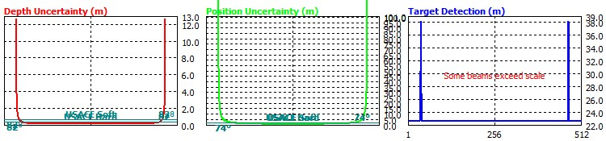

General |  | Tuning Parameters
Angular Coverage (deg) | 210 | Amplitude/Phase Measurement Crossover (samples) | 12
Maximum Ping Rate (Hz) | 60 | Amplitude Detect Denominator | 6
Along Track Beam Width (deg) | 1.9
Across Track Beam Width (deg) | 0.9 | Estimation Graph Parameters
Pulse Length (ms) | 0.03 | Number of Beams | 512
Sector Steering Angle (deg) | 361 | Depth of Bottom (m) | 20
Frequency (kHz) | 400.0 | Roll Angle (deg) | 0.0
Receive Bandwidth (kHz) | 6 | Pitch Angle (deg) | 0.0
Range Sampling Resolution (m) | 0.0125

Environment
Speed of Sound (m/s) | 1529 | Sound Speed Sensor Uncertainty (m/s) | 0.50
Peak-to-Peak Swell (m) | 1.0 | Surface Sound Speed Uncertainty (m/s) | 0.25
F-A Seafloor Slope (deg) | 0.0 | Spatio-Temporal Variation (m/s) | 1.00
P-S Seafloor Slope (deg) | 0.0 | Thickness of S-T Layer (m) | 10.0
Water Level Uncertainty (m) | 0.02 | Sound Speed Uncertainty Beyond SV Profile | 0.00
Spatial Tide Prediction Uncertainty (m) | 0.02 | Maximum Depth of SV Profile | 21.0

Sensor Info
 | Physical Offsets |  |  | Sensor Offset Uncertainty
 | Position | MRU | Transducer | Position | MRU | Transducer
Starboard | 0.00 | 0.00 | 0.00 | 0.01 | 0.01 | 0.01
Forward | 0.00 | 0.00 | 0.00 | 0.01 | 0.01 | 0.01
Vertical (+ Down) | 0.00 | 0.00 | 0.00 | 0.01 | 0.01 | 0.01

Survey Speed (kts) | 5.0 | Fixed Heave Uncertainty (m) | 0.02
Speed Uncertainty (m/s) | 0.1 | Heave (% of Heave Amplitude) | 5.00
Roll Offset Angle of Transducer (deg) | 0.00 | Roll Sensor Uncertainty (deg) | 0.02
Pitch Offset Angle of Transducer (deg) | 0.00 | Pitch Sensor Uncertainty (deg) | 0.02
Heading Offset Angle of Transducer (deg) | 0.00 | Roll Offset Uncertainty (deg) | 0.05
Transducer Draft (m) | 1.050 | Pitch Offset Uncertainty (deg) | 0.50
 |  | Yaw Offset Uncertainty (deg) | 0.50
Positioning System Uncertainty (m) dmrs | 0.07 | Positioning Time Lag (ms) | 0.20
Heading Uncertainty (deg) | 0.02 | MRU Time Lag (s) | 0.005
 |  | Transducer Time Lag (s) | 0.005
Draft Uncertainty (m) | 0.02 | Latency (s) | 0.000
Squat Uncertainty (m) | 0.02
Loading Changes (m) | 0.02

